Choose the correct alternative as per the question.
1. If 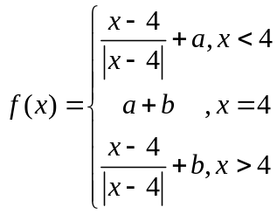 is continuous at x = 4, find a and b.
a) a = -1, b = 1
b) a = 1, b = 1
c) a = 1, b = -1
d) a = -1, b = -1
2. Find k such that the function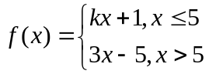 is continuous at x = 5.
a) 9/5
b) 5/9
c) -9/5
d) Not continuous for any k

3. If 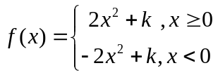 the for what value of k is f(x) continuous at x = 0?
a) 0
b) 1
c) For any value of k
d) For no value of k

4. If 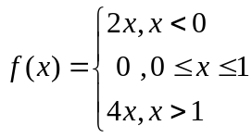 , then which of the following is false?
a) 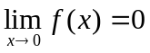
b) f is continuous for all values of x less than 1
c) f is continuous for all values of x greater than 1
d) f is continuous at x = 1.

5. If 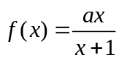 , x ≠ -1, then for which value of a is f (f(x)) = x
a) 
b) 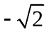
c) 1
d) -1

6. Let f : X → Y and g : Y → Z. Let h = g ◦ f : X → Z. Suppose g is one-to-one and
onto. Which of the following is FALSE?
a) If f is one-to-one then h is one-to-one and onto.
b) If f is not onto then h is not onto.
c) If f is one-to-one then h is one-to-one.
d) If f is onto then h is onto.

7. What is the domain for the function g(x) = ln(x-3)?
a) R
b) 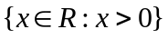
c) 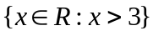
d) 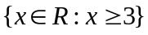

8. Which of the following is the most suitable answer?
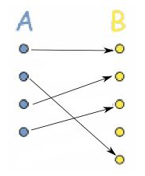
- It is a function
- One one but not onto
- Onto but not one one
- Bijective

9. Which of the following functions is NOT injective?
a) f(x) = cos x from [0, ] to R
b) f(x) = cos x from (0, 2)
c) f(x) = cos x from [0, ] to [-1,1]
d) f(x) = tan x from [0, /2 ) to R

10. The domain in which f(x) = x² becomes injective function is
a) R
b) R⁺
c) N
d) Z

11. The range for which y² = x becomes a function is
a) R
b) N
c) R⁺
d) (0, ∞)

12. 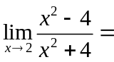
a) 1
b) 0
c) -1
d) ∞

13. Which of the following functions from 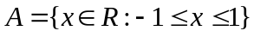 to itself are
bijections?
a) 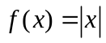
b) 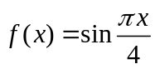
c) 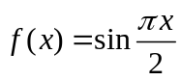
d) None of these

14. Let f(x) be defined by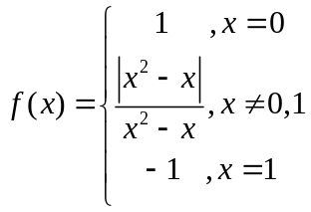 then which of the following
is true?
a) f is continuous for all x less than 1
b) f is continuous for all x less than 0
c) f is continuous for all x less than or equal to 1
d) f is continuous for all x more than or equal to 0

15. The range for the following function is

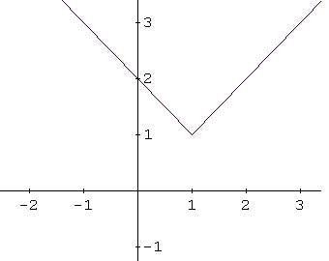
a) (-∞, ∞)
b) [1, ∞)
c) (-∞, 1]
d) [1, 3]

